Car Rental System

1. Creating the tables.

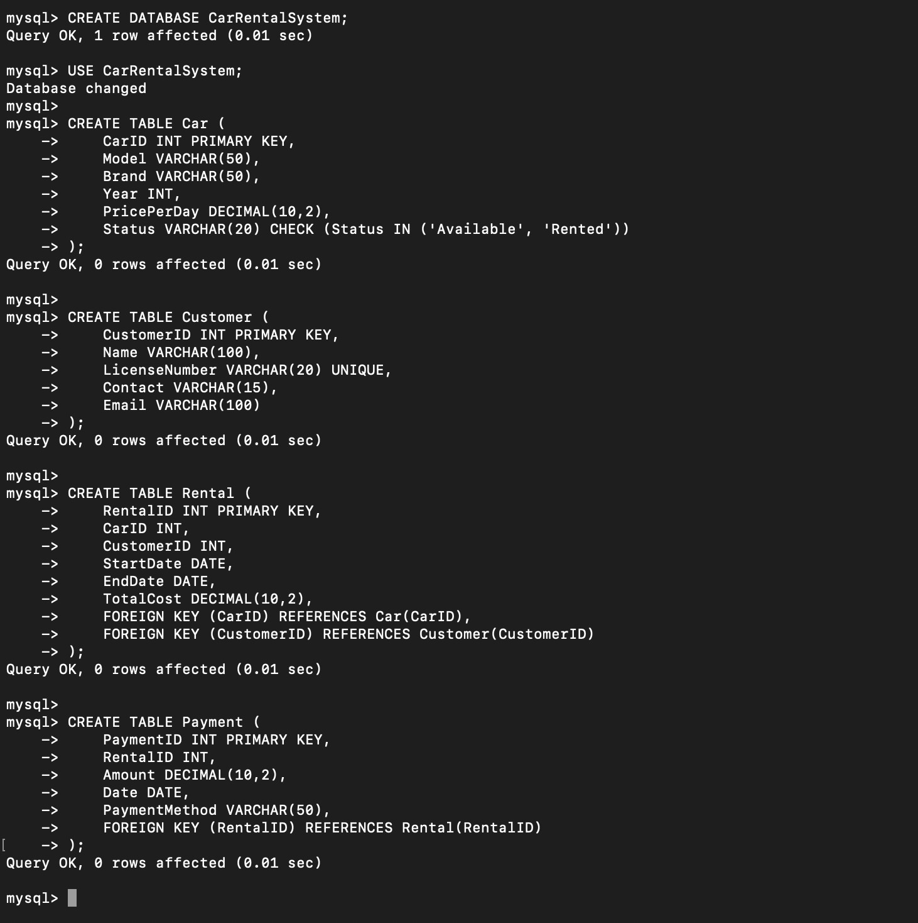

1. Inserting sample data.

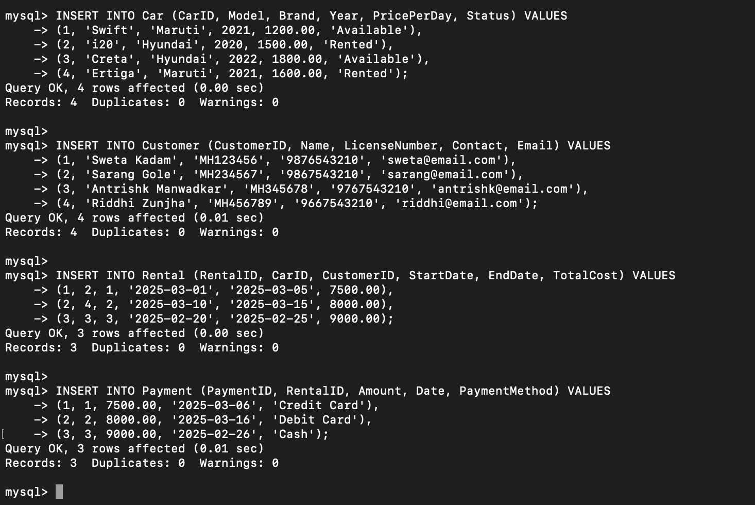

1. Retrieve all cars available for rent.

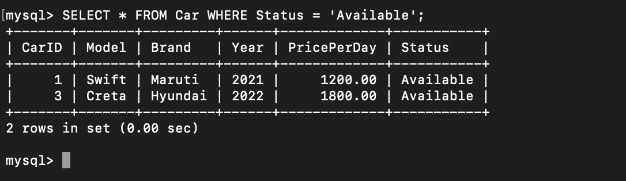

1. Find customers who have rented a car more than twice.

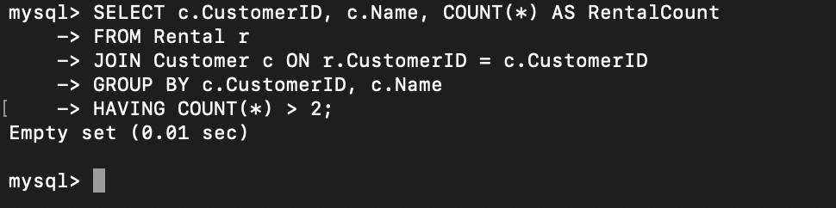

1. Retrieve total revenue per car model.

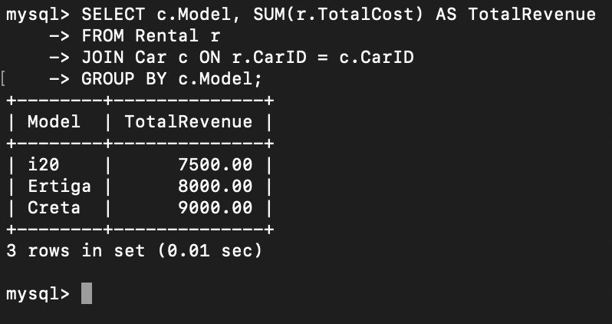

1. Display rental details for the past month.

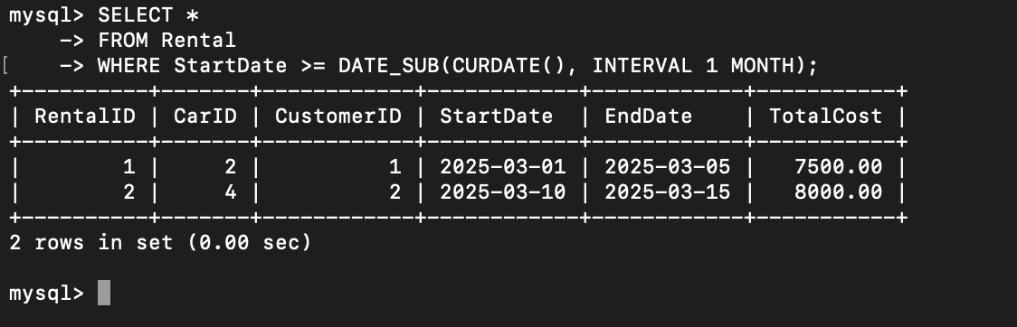

1. Find overdue rentals (where the return date has passed).

